**Pertemuan 1 : HTML**

**Tugas 1 : Hubungan Akrab**

|  |  |
| --- | --- |
| **Nama / Nim** | **: Nayura Arsineda / 2218022** |
| **Kelas** | **: A** |
| **Pengajar** | **: Fadhli Ilham Nafi'an Yuswono (2318001)** |

* 1. **Tujuan**

1. Mampu memahami struktur dasar HTML.
2. Mampu memahami fungsi tag – tag dasar HTML.
3. Mampu membuat halaman web menggunakan HTML.
   1. **Alat dan Bahan**
4. Laptop/pc
5. Modul Praktikum Web 2024
6. TextEditor (Visual Studio Code / Sublime Text)
   1. **Langkah-langkah**
7. Index.html

Source code :

|  |
| --- |
| <!DOCTYPE html>  <html lang="en">  <head>  <meta charset="UTF-8">  <meta http-equiv="X-UA-Compatible" content="IE=edge">  <meta name="viewport" content="width=device-width, initial-scale=1.0">  <title>W-Banking - Home</title>  <style>  body {  margin: 0;  padding: 0;  font-family: 'Goudy Bookletter 1911', serif;  background: url('5.jpg') no-repeat center center fixed;  background-size: cover;  height: 100vh;  display: flex;  justify-content: center;  align-items: center;  text-align: center;  }  .overlay {  background-color: rgba(255, 255, 255, 0.9);  padding: 30px;  border-radius: 10px;  box-shadow: 0 4px 6px rgba(0, 0, 0, 0.1);  max-width: 800px;  width: 90%;  }  h1 {  font-size: 3em;  margin-bottom: 20px;  color: #333;  text-shadow: 2px 2px 4px rgba(0, 0, 0, 0.2);  }  p {  font-size: 1.5em;  margin-bottom: 30px;  color: #555;  }  a {  text-decoration: none;  color: #fff;  background-color: #333;  padding: 15px 30px;  border-radius: 5px;  margin-right: 10px;  transition: all 0.3s ease;  }  a:hover {  background-color: #555;  }  </style>  </head>  <body>  <div class="overlay">  <h1>W-BANK</h1>  <p>Finansial Solutions.</p>  <a href="login.html">Login</a>  <a href="register.html">Register</a>  </div>  </body>  </html> |

Hasil Tampilan :



Analisa :

Program ini merupakan dokumen HTML yang menampilkan halaman web dengan tampilan "W-BANK". Halaman ini berisi pilihan login dan register yang akan membawa pengguna masuk ke dalam halaman login atau register.

1. Login.html

Source code :

|  |
| --- |
| <!DOCTYPE html>  <html lang="en">  <head>  <meta charset="UTF-8">  <meta http-equiv="X-UA-Compatible" content="IE=edge">  <meta name="viewport" content="width=device-width, initial-scale=1.0">  <title>MBanking - Login</title>  <style>  body {  margin: 0;  padding: 0;  font-family: 'Goudy Bookletter 1911', serif;  background: url('background.jpg') no-repeat center center fixed;  background-size: cover;  height: 100vh;  display: flex;  justify-content: center;  align-items: center;  text-align: center;  }  .container {  background-color: rgba(255, 255, 255, 0.8);  padding: 30px;  border-radius: 10px;  box-shadow: 0 4px 6px rgba(0, 0, 0, 0.1);  max-width: 400px;  width: 90%;  position: relative;  z-index: 1;  }  h1 {  font-size: 2.5em;  margin-bottom: 20px;  color: #333;  text-shadow: 2px 2px 4px rgba(0, 0, 0, 0.3);  }  form {  margin-bottom: 20px;  }  label {  display: block;  margin-bottom: 5px;  text-align: left;  color: #555;  }  input[type="text"],  input[type="password"] {  width: 100%;  padding: 10px;  margin-bottom: 10px;  border-radius: 5px;  border: 1px solid #ccc;  box-sizing: border-box;  }  input[type="submit"] {  background-color: #007bff;  color: #fff;  padding: 10px 20px;  border: none;  border-radius: 5px;  cursor: pointer;  transition: background-color 0.3s;  }  input[type="submit"]:hover {  background-color: #0056b3;  }  a {  text-decoration: none;  color: #007bff;  margin-top: 10px;  display: inline-block;  margin-right: 10px;  }  img {  width: 100%;  height: auto;  position: absolute;  top: 0;  left: 0;  z-index: 0;  }  </style>  </head>  <body>  <img src="3.jpg" alt="Background Image">  <div class="container">  <h1>Login to W-Bank Account</h1>  <form action="login.php" method="POST">  <label for="username">Username:</label><br>  <input type="text" id="username" name="username"><br>  <label for="password">Password:</label><br>  <input type="password" id="password" name="password"><br>  <input type="submit" value="Login">  </form>  <a href="Landing Page.html">Back</a>  <a href="register.html">Register</a>  </div>  </body>  </html> |

Hasil Tampilan :

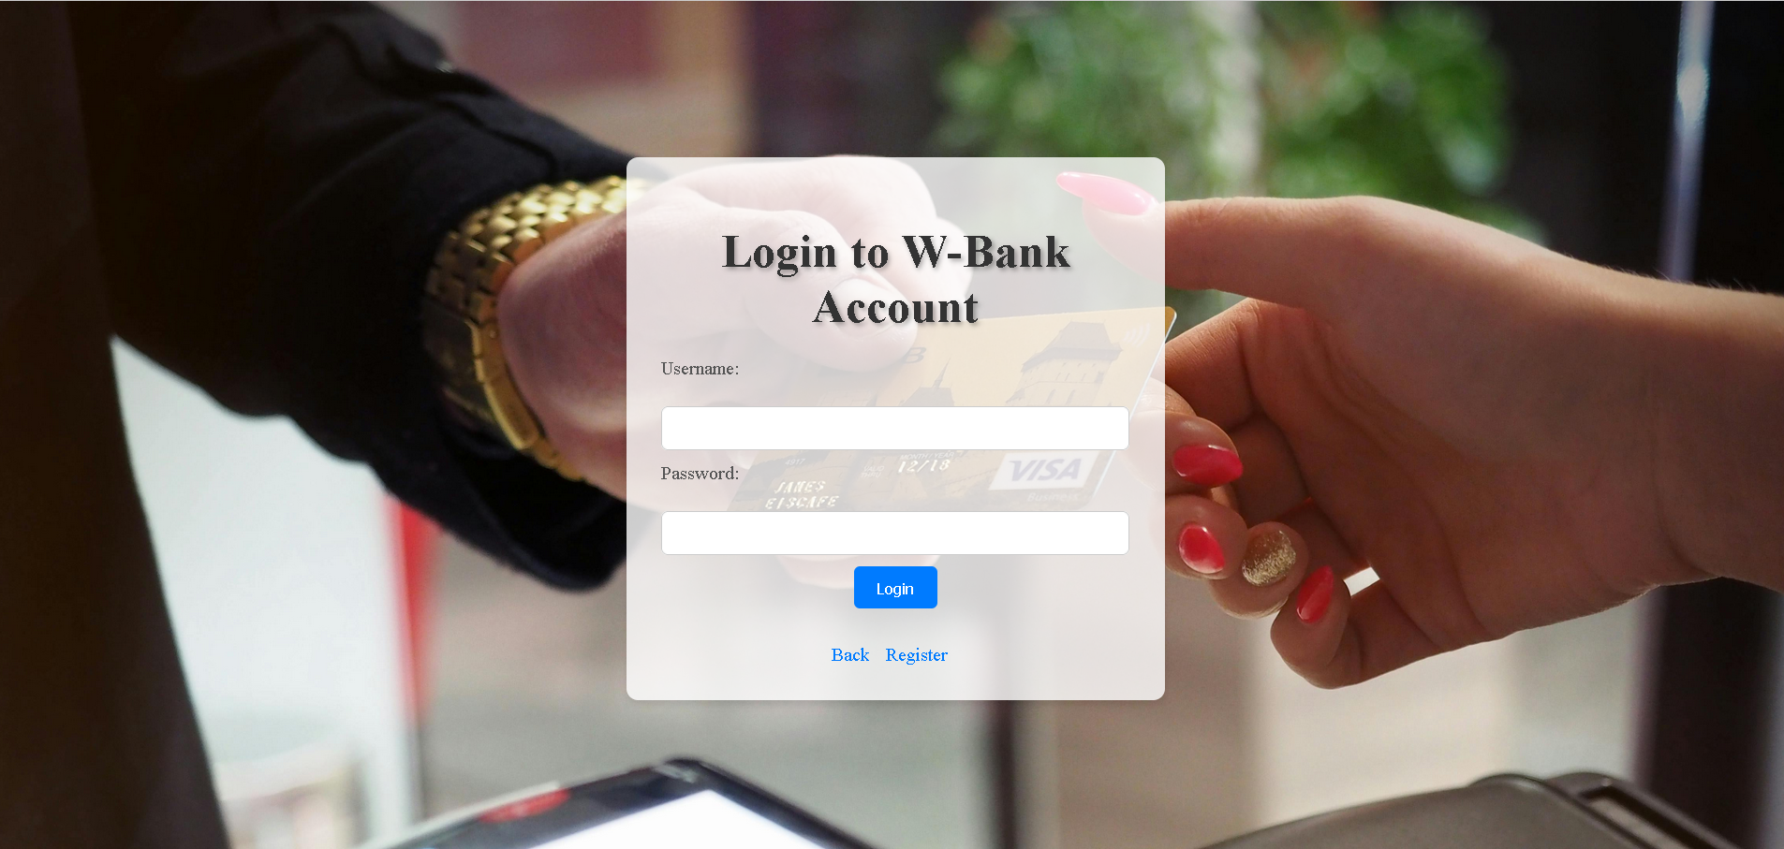

Analisa :

Program ini digunakan untuk membuat halaman login dengan formulir untuk memasukkan username dan password, dan untuk menuju halaman registrasi jika pengguna belum mempunyai akun. Dan terdapat tombol back untuk kembali ke menu halaman utama

1. Register.html

Source code :

|  |
| --- |
| <!DOCTYPE html>  <html lang="en">  <head>  <meta charset="UTF-8">  <meta http-equiv="X-UA-Compatible" content="IE=edge">  <meta name="viewport" content="width=device-width, initial-scale=1.0">  <title>MBanking - Register</title>  <style>  body {  margin: 0;  padding: 0;  font-family: Arial, sans-serif;  background-color: #f9f9f9;  display: flex;  justify-content: center;  align-items: center;  min-height: 100vh;  }  .container {  background-color: #fff;  padding: 30px;  border-radius: 10px;  box-shadow: 0 4px 6px rgba(0, 0, 0, 0.1);  max-width: 800px;  width: 90%;  display: grid;  grid-template-columns: 1fr 1fr;  grid-gap: 20px;  }  .form-container {  display: flex;  flex-direction: column;  justify-content: center;  align-items: center;  padding: 20px;  grid-column: 1 / span 1;  }  h1 {  font-size: 2.5em;  margin-bottom: 20px;  color: #333;  }  form {  width: 100%;  }  label {  display: block;  margin-bottom: 5px;  text-align: left;  color: #555;  }  input[type="text"],  input[type="password"],  input[type="email"] {  width: 100%;  padding: 10px;  margin-bottom: 10px;  border-radius: 5px;  border: 1px solid #ccc;  box-sizing: border-box;  }  input[type="submit"] {  background-color: #007bff;  color: #fff;  padding: 10px 20px;  border: none;  border-radius: 5px;  cursor: pointer;  transition: background-color 0.3s;  }  input[type="submit"]:hover {  background-color: #0056b3;  }  a {  text-decoration: none;  color: #007bff;  margin-top: 10px;  display: inline-block;  margin-right: 10px;  }  .image-container {  border-radius: 10px;  overflow: hidden;  grid-column: 2 / span 1;  position: relative;  }  .image-container img {  width: 100%;  height: 100vh;  object-fit: cover;  filter: grayscale(80%);  transition: filter 0.3s;  }  .image-container:hover img {  filter: grayscale(0);  }  .overlay {  position: absolute;  top: 0;  left: 0;  width: 100%;  height: 100%;  background-color: rgba(0, 0, 0, 0.5);  display: flex;  justify-content: center;  align-items: center;  opacity: 0;  transition: opacity 0.3s;  }  .overlay:hover {  opacity: 1;  }  .overlay-content {  text-align: center;  color: #fff;  }  .overlay-content h2 {  font-size: 2em;  margin-bottom: 10px;  }  .overlay-content p {  font-size: 1.2em;  }  </style>  </head>  <body>  <div class="container">  <div class="form-container">  <h1>Register</h1>  <form action="register.php" method="POST">  <label for="username">Username:</label><br>  <input type="text" id="username" name="username"><br>  <label for="password">Password:</label><br>  <input type="password" id="password" name="password"><br>  <label for="email">Email:</label><br>  <input type="email" id="email" name="email"><br>  <input type="submit" value="Register">  </form>  <a href="login.html">Login</a>  </div>  <div class="image-container">  <img src="cc2.jpg" alt="Register Image">  <div class="overlay">  <div class="overlay-content">  <h2>YOUR TEMPLATE CREDIT CARD</h2>  <p>W-BANK Financial Solution</p>  </div>  </div>  </div>  </div>  </body>  </html> |

Hasil Tampilan :

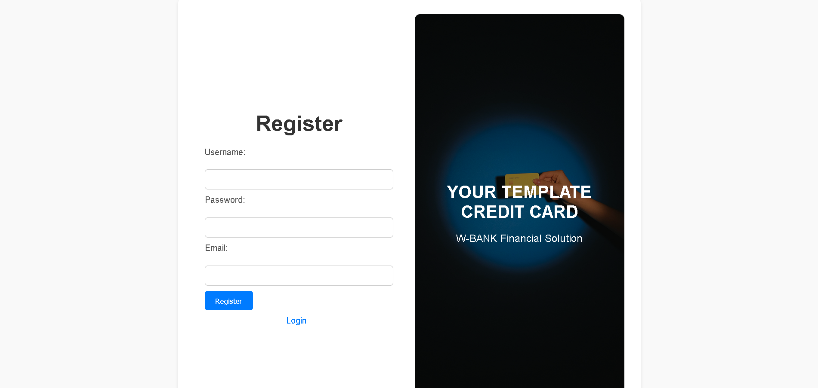

Analisa :

Program ini digunakan untuk menampilkan halaman register dengan formular untuk memasukkan username, password dan email, serta tautan untuk menuju halaman login jika pengguna sudah mempunyai email.